- 陣列帕斯卡
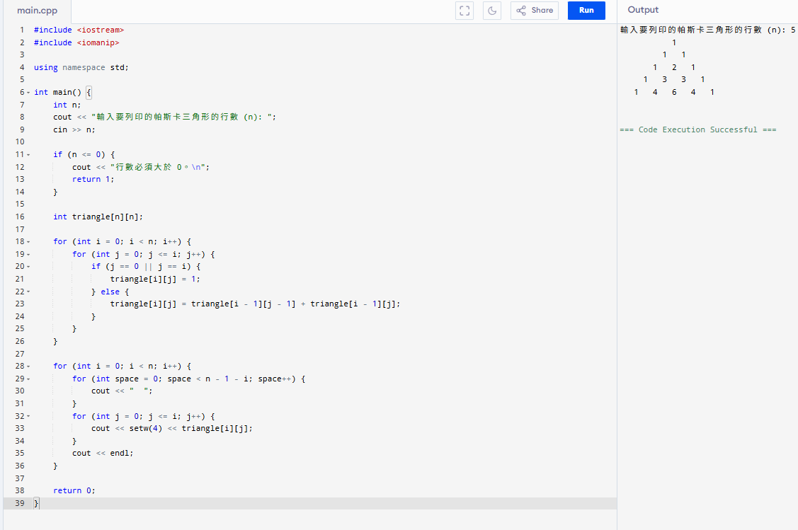

#include <iostream>
#include <iomanip>

using namespace std;

int main() {
int n;
cout << "輸入要列印的帕斯卡三角形的行數 (n): ";
cin >> n;

if (n <= 0) {
cout << "行數必須大於 0。\n";
return 1;
}

int triangle[n][n];

for (int i = 0; i < n; i++) {
for (int j = 0; j <= i; j++) {
if (j == 0 || j == i) {
triangle[i][j] = 1;
} else {
triangle[i][j] = triangle[i - 1][j - 1] + triangle[i - 1][j];
}
}
}

for (int i = 0; i < n; i++) {
for (int space = 0; space < n - 1 - i; space++) {
cout << " ";
}
for (int j = 0; j <= i; j++) {
cout << setw(4) << triangle[i][j];
}
cout << endl;
}

return 0;
}
2.向量帕斯卡
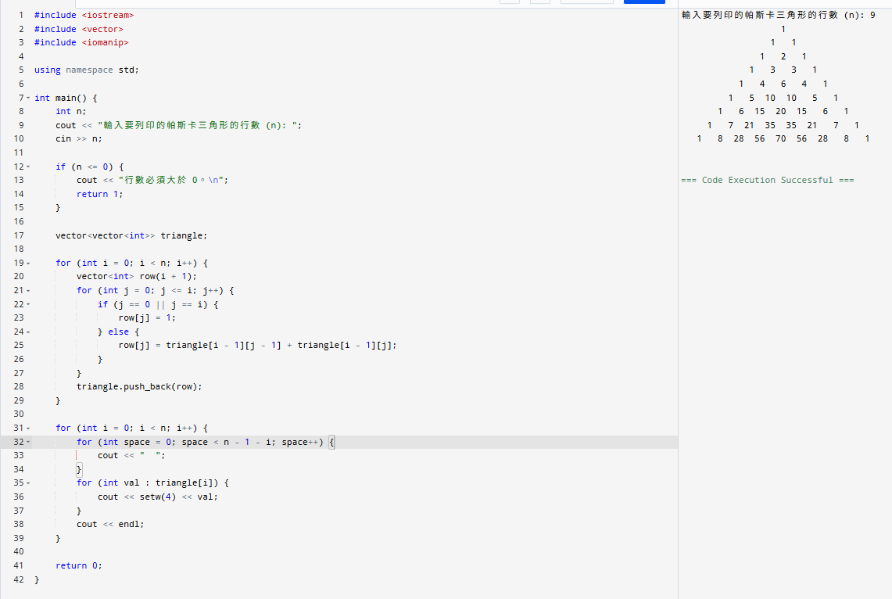
#include <iostream>
#include <vector>
#include <iomanip>

using namespace std;

int main() {
int n;
cout << "輸入要列印的帕斯卡三角形的行數 (n): ";
cin >> n;

if (n <= 0) {
cout << "行數必須大於 0。\n";
return 1;
}

vector<vector<int>> triangle;

for (int i = 0; i < n; i++) {
vector<int> row(i + 1);
for (int j = 0; j <= i; j++) {
if (j == 0 || j == i) {
row[j] = 1;
} else {
row[j] = triangle[i - 1][j - 1] + triangle[i - 1][j];
}
}
triangle.push_back(row);
}

for (int i = 0; i < n; i++) {
for (int space = 0; space < n - 1 - i; space++) {
cout << " ";
}
for (int val : triangle[i]) {
cout << setw(4) << val;
}
cout << endl;
}

return 0;
}

3. 學生姓名與分數排序
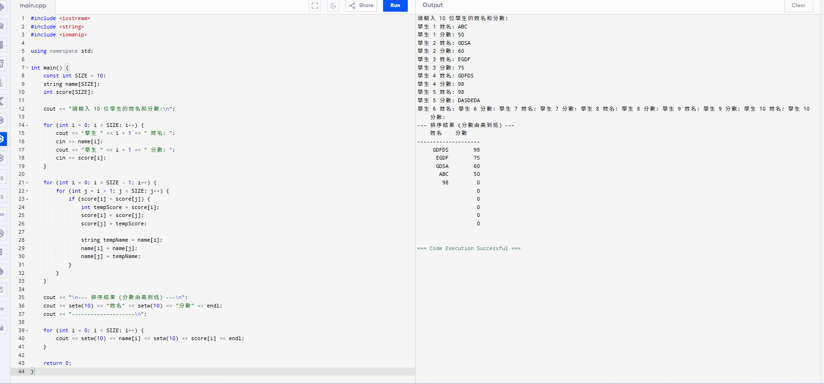
#include <iostream>
#include <string>
#include <iomanip>

using namespace std;

int main() {
const int SIZE = 10;
string name[SIZE];
int score[SIZE];

cout << "請輸入 10 位學生的姓名和分數:\n";

for (int i = 0; i < SIZE; i++) {
cout << "學生 " << i + 1 << " 姓名: ";
cin >> name[i];
cout << "學生 " << i + 1 << " 分數: ";
cin >> score[i];
}

for (int i = 0; i < SIZE - 1; i++) {
for (int j = i + 1; j < SIZE; j++) {
if (score[i] < score[j]) {
int tempScore = score[i];
score[i] = score[j];
score[j] = tempScore;

string tempName = name[i];
name[i] = name[j];
name[j] = tempName;
}
}
}

cout << "\n--- 排序結果 (分數由高到低) ---\n";
cout << setw(10) << "姓名" << setw(10) << "分數" << endl;
cout << "--------------------\n";

for (int i = 0; i < SIZE; i++) {
cout << setw(10) << name[i] << setw(10) << score[i] << endl;
}

return 0;
}
4. 模仿 strcpy() 函式
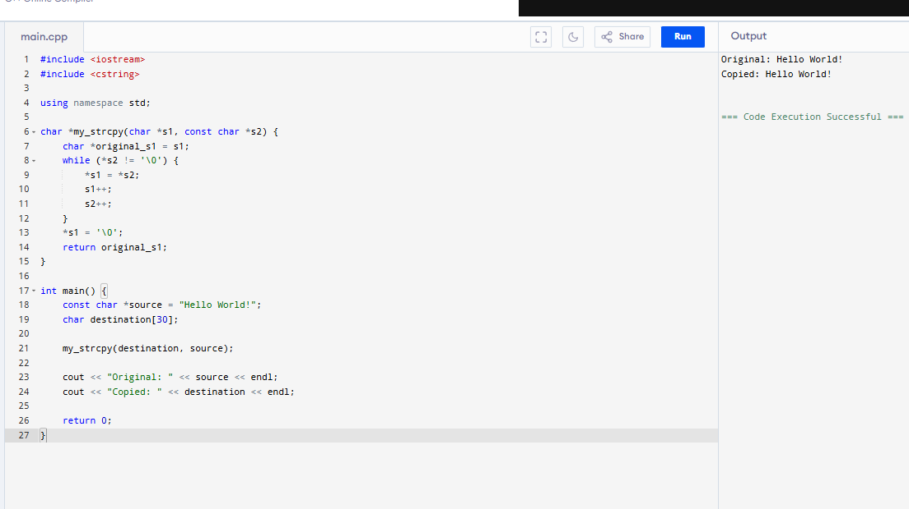
#include <iostream>
#include <cstring>

using namespace std;

char *my_strcpy(char *s1, const char *s2) {
char *original_s1 = s1;
while (*s2 != '\0') {
*s1 = *s2;
s1++;
s2++;
}
*s1 = '\0';
return original_s1;
}

int main() {
const char *source = "Hello World!";
char destination[30];

my_strcpy(destination, source);

cout << "Original: " << source << endl;
cout << "Copied: " << destination << endl;

return 0;
}
5. 模仿 strcat() 函式
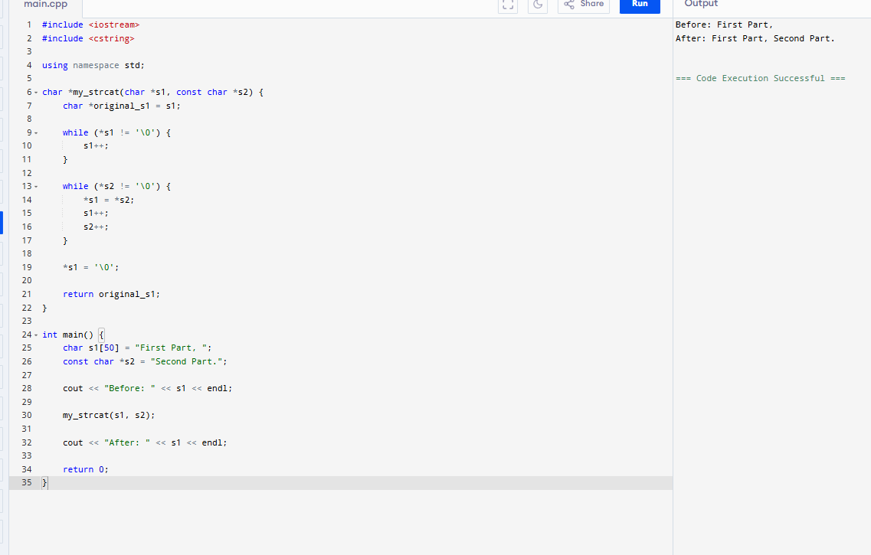
#include <iostream>
#include <cstring>

using namespace std;

char *my_strcat(char *s1, const char *s2) {
char *original_s1 = s1;

while (*s1 != '\0') {
s1++;
}

while (*s2 != '\0') {
*s1 = *s2;
s1++;
s2++;
}

*s1 = '\0';

return original_s1;
}

int main() {
char s1[50] = "First Part, ";
const char *s2 = "Second Part.";

cout << "Before: " << s1 << endl;

my_strcat(s1, s2);

cout << "After: " << s1 << endl;

return 0;
}

6. 模仿 strcmp() 函式
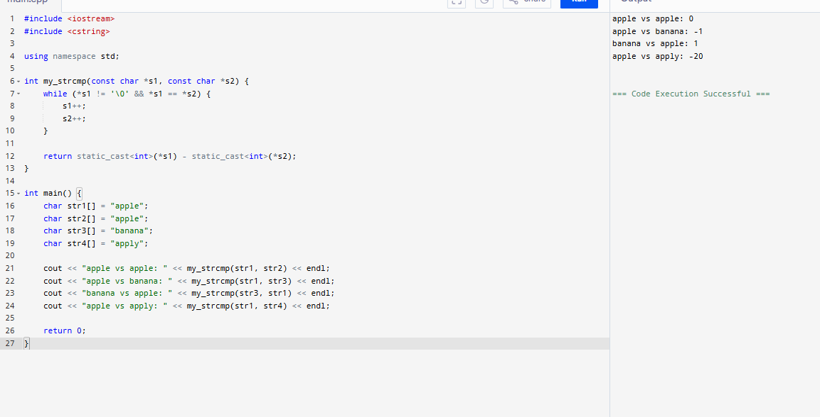

#include <iostream>
#include <cstring>

using namespace std;

int my_strcmp(const char *s1, const char *s2) {
while (*s1 != '\0' && *s1 == *s2) {
s1++;
s2++;
}

return static_cast<int>(*s1) - static_cast<int>(*s2);
}

int main() {
char str1[] = "apple";
char str2[] = "apple";
char str3[] = "banana";
char str4[] = "apply";

cout << "apple vs apple: " << my_strcmp(str1, str2) << endl;
cout << "apple vs banana: " << my_strcmp(str1, str3) << endl;
cout << "banana vs apple: " << my_strcmp(str3, str1) << endl;
cout << "apple vs apply: " << my_strcmp(str1, str4) << endl;

return 0;
}

